**PIZZA SALES SQL QUERIES**

**A. KPI’s**

**1. Total Revenue:**

SELECT SUM(total_price) AS Total_Revenue FROM pizza_sales;

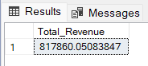

**2. Average Order Value**

SELECT SUM(total_price) / MAX(order_id) AS Avg_Order_Value FROM pizza_sales;

Or

SELECT SUM(total_price) / COUNT(DISTINCT order_id) AS Avg_Order_Value FROM pizza_sales;

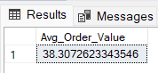

**3. Total Pizzas Sold**

SELECT SUM(quantity) AS Total_Pizza_Sold FROM pizza_sales;

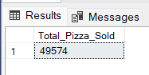

**4. Total Orders**

SELECT COUNT(DISTINCT order_id) AS Total_Orders FROM pizza_sales;

Or

SELECT MAX(order_id) AS Total_Orders FROM pizza_sales;

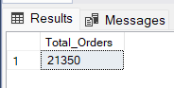

**5. Average Pizzas Per Order**

SELECT CAST(CAST(SUM(quantity) AS DECIMAL(10,2)) / CAST(COUNT(DISTINCT order_id) AS DECIMAL(10,2)) AS DECIMAL(10,2)) AS Average_Pizza_Per_Order FROM pizza_sales;

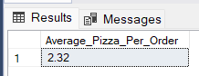

**B. CHARTS REQUIREMENT**

**1. Daily Trend for Total Orders**

SELECT DATENAME(DW, order_date) AS order_day, COUNT(DISTINCT order_id) AS Total_orders

FROM pizza_sales

GROUP BY DATENAME(DW, order_date)

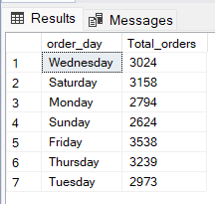

**2. Hourly Trend for Total Orders**

SELECT DATEPART(HOUR, order_time) AS order_hours, COUNT(DISTINCT order_id) AS Total_orders

FROM pizza_sales

GROUP BY DATEPART(HOUR, order_time)

ORDER BY DATEPART(HOUR, order_time)

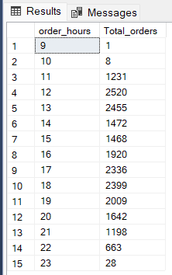

**3. Percentage of Sales by Pizza Category**

SELECT pizza_category, SUM(total_price) AS Total_Sales, SUM(total_price) * 100 / (SELECT SUM(total_price) FROM pizza_sales) AS PCT

FROM pizza_sales

GROUP BY pizza_category

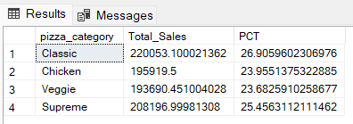

**4. Percentage of Sales by Pizza Size**

SELECT pizza_size, SUM(total_price) AS Total_Sales, CAST(SUM(total_price) * 100 / (SELECT SUM(total_price) FROM pizza_sales) AS DECIMAL(10,2)) AS PCT

FROM pizza_sales

GROUP BY pizza_size

ORDER BY PCT DESC

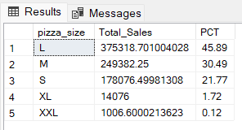

**5. Total Pizzas Sold by Pizza Category**

SELECT pizza_category, SUM(quantity) AS Total_Pizzas

FROM pizza_sales

GROUP BY pizza_category

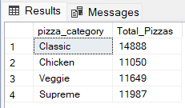

**6. Top 5 Best Sellers by Revenue, Total Quantity and Total Orders**

*A) By revenue*

SELECT TOP 5 pizza_name, SUM(total_price) AS Total_Revenue FROM pizza_sales

GROUP BY pizza_name

ORDER BY Total_Revenue DESC

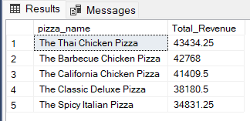

*B) By Total Quantity*

SELECT TOP 5 pizza_name, SUM(quantity) AS Total_Quantity FROM pizza_sales

GROUP BY pizza_name

ORDER BY Total_Quantity DESC

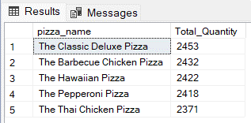

*C) By Total Orders*

SELECT TOP 5 pizza_name, COUNT(DISTINCT order_id) AS Total_Orders FROM pizza_sales

GROUP BY pizza_name

ORDER BY Total_Orders DESC

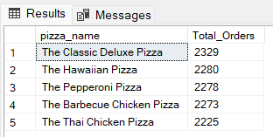

**7. Bottom 5 Best Sellers by Revenue, Total Quantity and Total Orders**

*A) By revenue*

SELECT TOP 5 pizza_name, SUM(total_price) AS Total_Revenue FROM pizza_sales

GROUP BY pizza_name

ORDER BY Total_Revenue

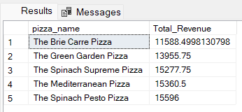

*B) By Total Quantity*

SELECT TOP 5 pizza_name, SUM(quantity) AS Total_Quantity FROM pizza_sales

GROUP BY pizza_name

ORDER BY Total_Quantity

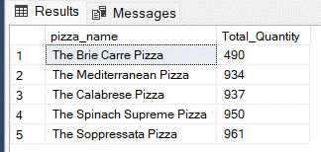

*C) By Total Orders*

SELECT TOP 5 pizza_name, COUNT(DISTINCT order_id) AS Total_Orders FROM pizza_sales

GROUP BY pizza_name

ORDER BY Total_Orders

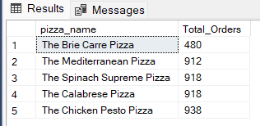

***NOTE***

If you want to apply the Month, Quarter, Week filters to the above queries you

can use WHERE clause. Follow some of below examples

SELECT DATENAME(MONTH, order_date) AS Month_name, COUNT(DISTINCT order_id) AS Total_orders

FROM pizza_sales

WHERE MONTH(order_date) = 1

GROUP BY DATENAME(MONTH, order_date)

*\*Here MONTH(order_date) = 1 indicates that the output is for the month of January.*

*MONTH(order_date) = 4 indicates that the output is for Month of April*

SELECT DATENAME(MONTH, order_date) AS Month_name, COUNT(DISTINCT order_id) AS Total_orders

FROM pizza_sales

WHERE DATEPART(QUARTER, order_date) = 1

GROUP BY DATENAME(MONTH, order_date)

*\*Here DATEPART(QUARTER, order_date) = 1 indicates that the output is for the Quarter 1.*

*DATEPART(QUARTER, order_date) = 3 indicates that the output is for Quarter 3*